Functions

Q) Concat(): Add Two strings together

select concat(FIRST_NAME,LAST_NAME)Name

from EMPLOYEES

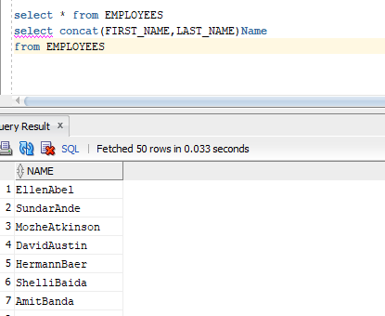

Q) substr(): Extracts some charcter from string

select substr('sri,padmavathi mahila_university',4,4)from dual;

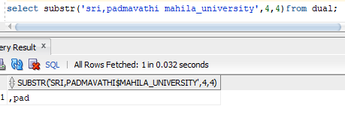

Q)Length(): Length of the text

select length(email)as length

from EMPLOYEES

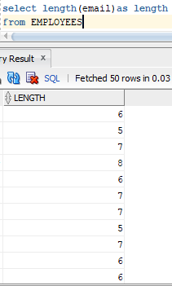

Q)Lpad():

left padded to length in n charcters

select lpad('document starting with',30,'*.')

from dual

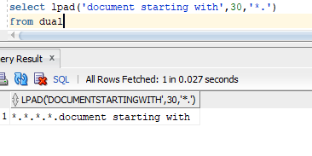

Q)Rpad()

select rpad('document starting with',27,'*.')as rpad

from dual

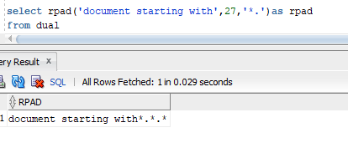

Assignment-4

Q) Split the word **"shiva sai shankar"** into first, middle and last names

create table Split_table(Name char(55))

insert into Split_table values('siva sai sankar')

select * from Split_table

select substr(Name,1,5)first_name,substr(Name,6,3)middle_name,substr(Name,9,7)

from Split_table

(or)

select split_part(Name,' ',1)first_name,split_part(Name,' ',2)middle_name,

split_part(Name,' ',3)last_name from Split_table

(or)

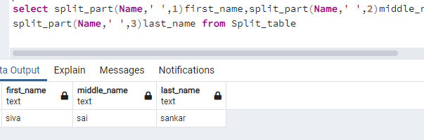

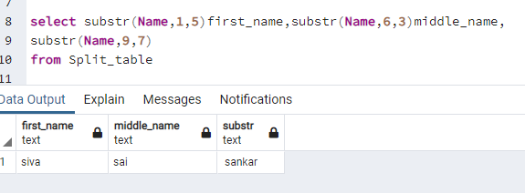

Q)Write a SQL Query which includes all basic keywords and explain with steps for Order of Execution?

Select col1,col2,coln,sum(col n)

From table name (emp)

Join another_table(dept)

On (emp)tname.common_col=(dept)tname.common_col

Where condition(col1=’abc’)

Group by col1,col2

Having sum(col n)>abc

Order by col 1 asc/desc

Query Order of execution:

step 1: from : The from clause are first executed to determine the total working set of data

that is being

Step:2 joins

step 3:on

step 4:where

step 5:group by

Step 6:having

step 7:select

step 8:order by asc/desc

4) Create a table with columns: id, date field with 2018 -2020 dates and salary (3 columns)

